|  |
| --- |
| **I DID NOT KNOW ABOUT THIS PLACE.** |

When visitors first enter the museum, they will hear a sound like wind chimes coming from above them and their attention will be drawn upward 24 feet to the ceiling of the two-story high atrium.  
  
Dog tags of the more than 58,000 service men and women who died in the Vietnam War hang from the ceiling of the National Vietnam Veterans Art Museum in Chicago on Veterans Day, November 11, 2010. The 10-by-40-foot sculpture, entitled Above & Beyond, was designed by Ned Broderick and Richard Steinbock.

The tens of thousands of metal dog tags are suspended 24 feet in the air, 1 inch apart, from fine lines that allow them to move and chime with shifting air currents. Museum employees using a kiosk and laser pointer help visitors locate the exact dog tag with the imprinted name of their lost friend or relative.

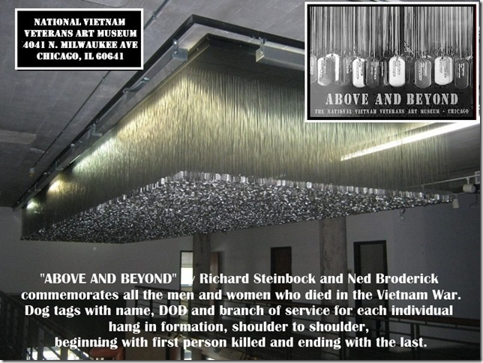

**"If you can read this, thank a Teacher........If you are reading it in English, thank a VET"**