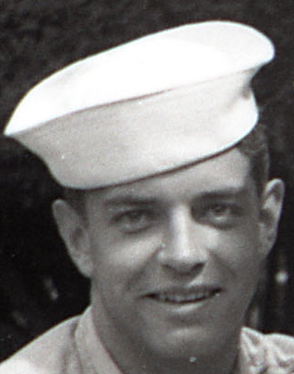
Gene Bradley ‘Brad’ Haun, 80, died peacefully at home, January 19, 2012, after a long struggle with Alzheimer’s.
He was born-at-home to Susan (Cox) and Chet Haun on July 12, 1931, and raised in Lewistown, Montana. After graduating from Fergus High, Gene married his sweetheart, Nora Monkelin, also of Lewistown. He then enlisted in the Navy, following in the footsteps of his father and sister. He served as a mechanic on PBM/P5M seaplane crews in the Philippines and Hong Kong during the Korean Conflict.
On his return stateside, he worked as a mail carrier for the United States Postal Service in Lewistown. Gene then moved his young family to Bozeman and enrolled at Montana State University on the GI Bill where he studied chemical engineering. After graduation, the degree allowed him to garner a job in the booming aerospace industry on the East Coast. Manned space flight was headed to the Moon!
For nearly a decade, Gene worked in fuel-cell testing for the Apollo missions at Pratt & Whitney Aircraft in East Hartford and South Windsor, Connecticut. When the space program collapsed in the early ‘70s, he moved the family back west to Spokane, Washington, to be closer to aging parents and his sister. He and Nora retrained in Baking/Culinary Arts and operated the Opportunity Bakery. After succumbing to the long hours of that endeavor, they sold the business and both took 9-5 jobs. Gene retired from Johnson-Matthey in Spokane’s Industrial Park in 1997.
In 2007, Gene and Nora sold the family home in Spokane to move further west to Seattle to be near their two youngest daughters and the grandkids. They really enjoyed the mild weather and being near family without the long drives over the Cascade passes.
Gene’s passion for driving included many trips to American states as well as provinces of Canada and in to Mexico. His love of cooking (and eating…) kept everyone happily fed over the years. The family is also grateful to have thousands of photographs he made in his youth and throughout his life.
Gene made the decision some time ago to donate his remains to the Willed Body Program at the University of Washington. A memorial service will be held in conjunction with the return of his ashes to the family at the conclusion of study, in two years’ time.
Gene was preceded in death by his brother, Dean; mother; father; and his sister, Bette. He is survived by his wife of 61 years, Nora, and daughters Debbi (Raleigh NC), Toni and Vicki (both of Seattle), as well as his uncle, Joe Nemec (Prescott AZ), sister-in-law Anita Staley, nephew Fred Staley, and nieces Candy Weppler and Kathy New (all of Hamilton OH), nieces Carolyn Stephens (Monroe OH) and Ronita Rehmel (Liberty IN), and seven grandchildren—Jennifer and Scott Miller; Michael, Trinity and Kelley Fagan; and Victoria and Alina Osaula.
Condolences can be sent to Nora at 18364 Ridgefield Road NW, Shoreline WA 98177. Memorials can be made to Mae’s Alzheimer’s Café, 6412 Phinney Ave N, Seattle WA 98103.

